SEEDING DATA

- Data seeding is the process of automatically populating a database with initial, default, or sample data when the database is created or updated.
- It ensures that certain important data already exists in the database before the application starts running.
- In others word:
  - Seeding data means inserting essential starting data into the database automatically

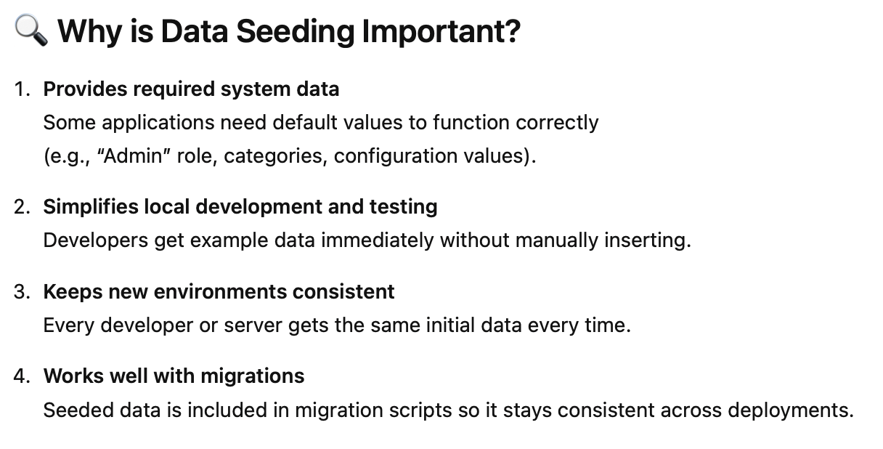

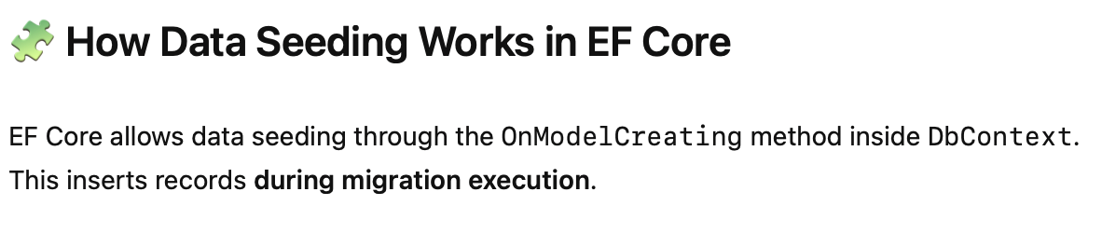

Step by Step Seeding Data Setup

- In infrastructure module create Seeders folder and create class library name RestaurantSeeder.cs.
- Make sure internal class as our dbcontext is internal
- The content as follows:
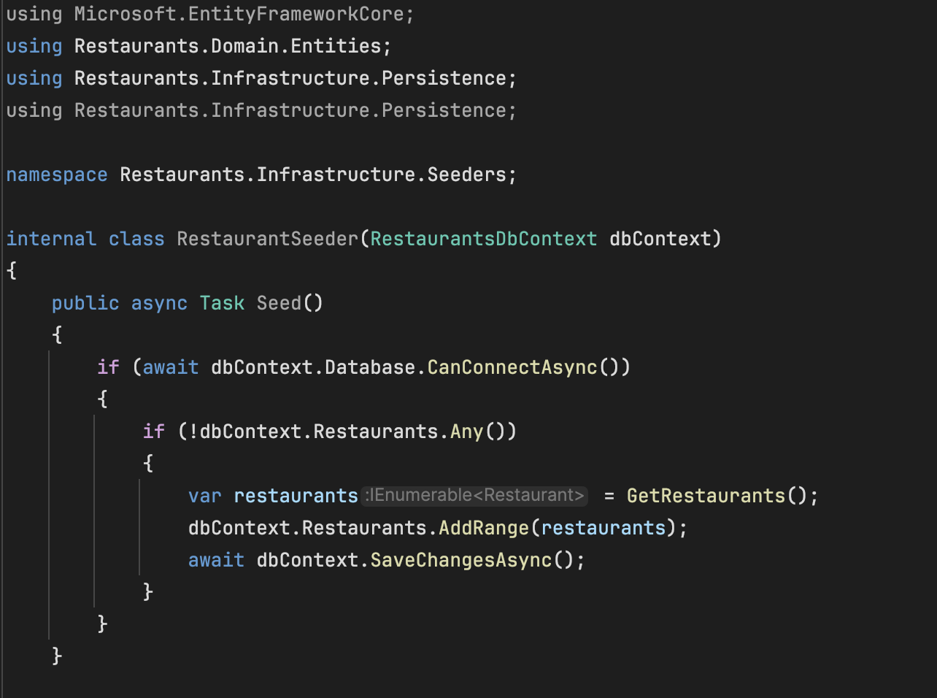
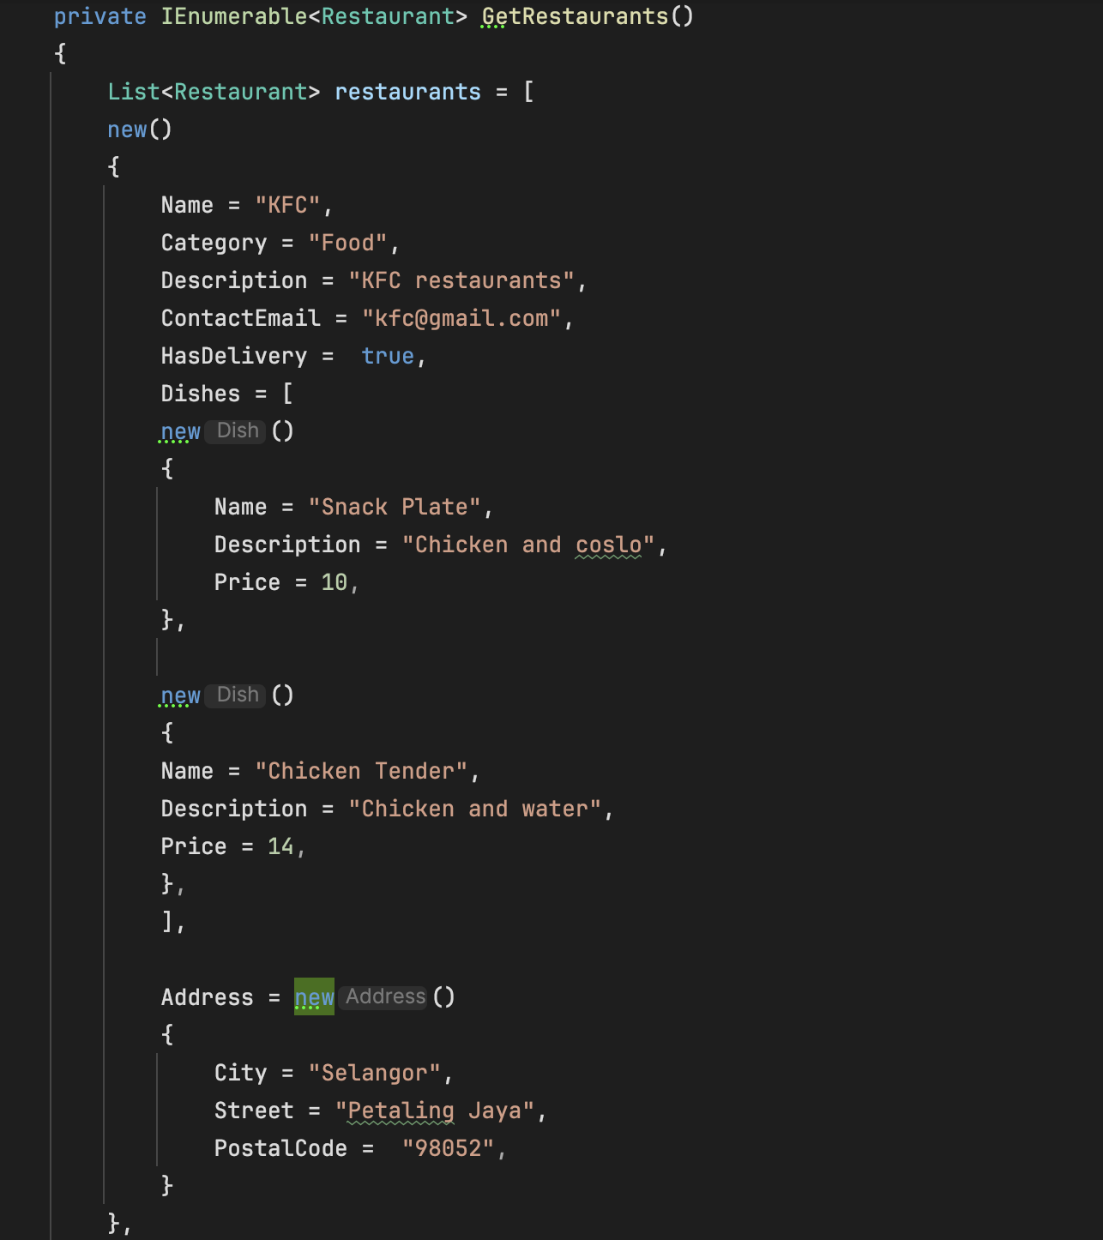

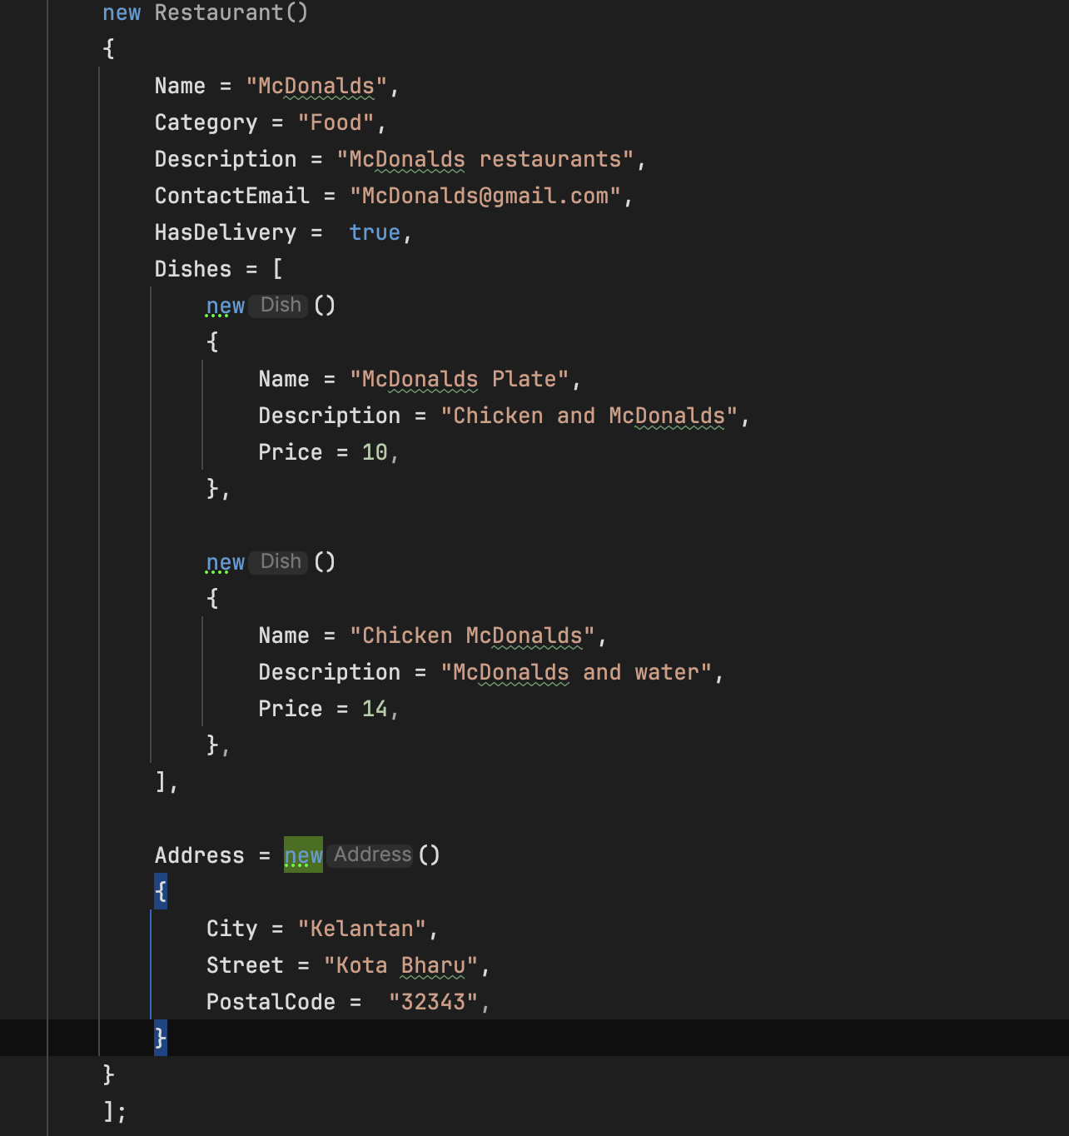
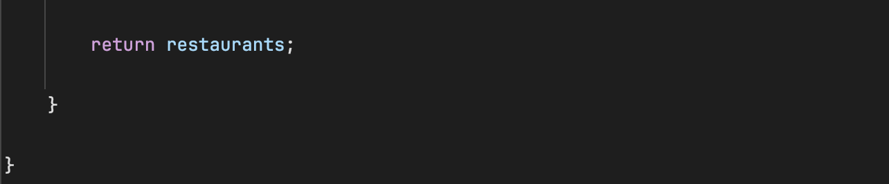

- Then we need to extract interface of this RestaurantSeeder.cs
- Right click the class name
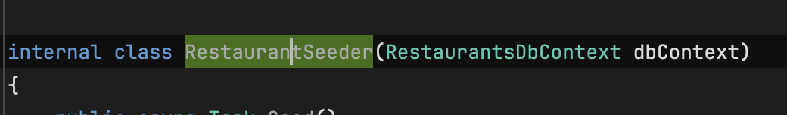
- Click Refactor > Extract Interface
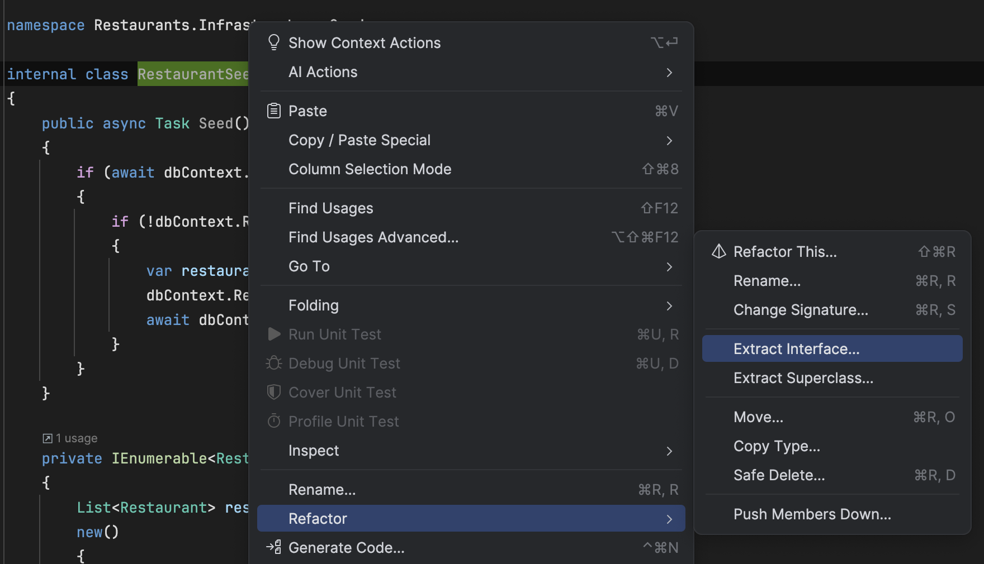

- Select own file and choose Seed ()
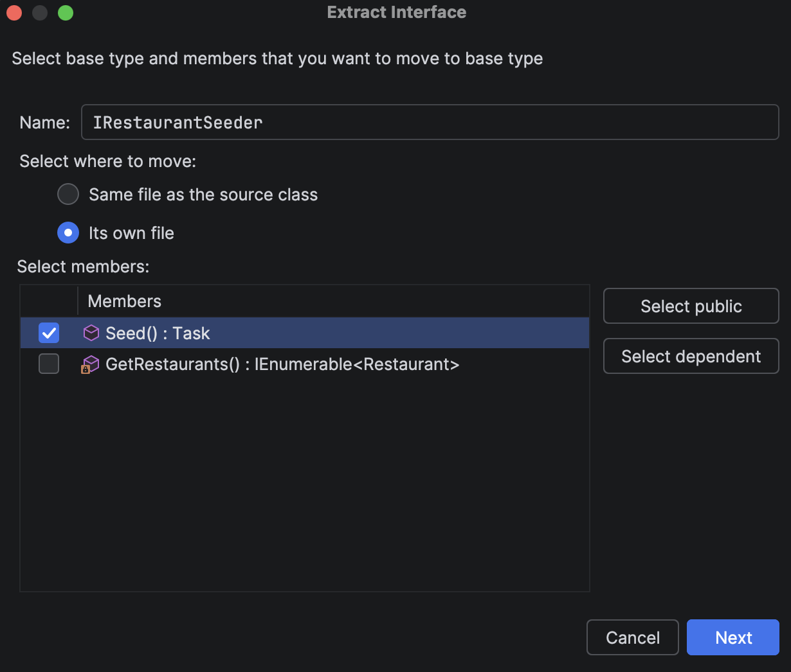
- File will be created like this but need to change the internal to public so we can use in program.cs later:
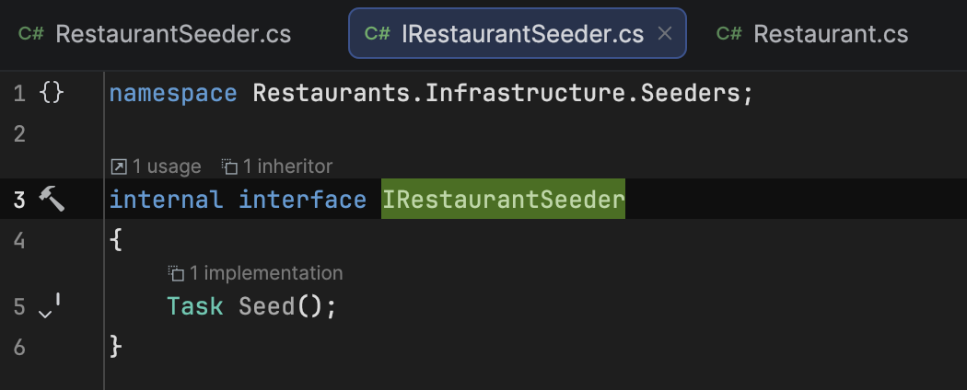
- Register our IRestaurantSeeder.cs in the ServiceCollectionExtensions.cs. Must AddScoped for IRestaurantSeeder:
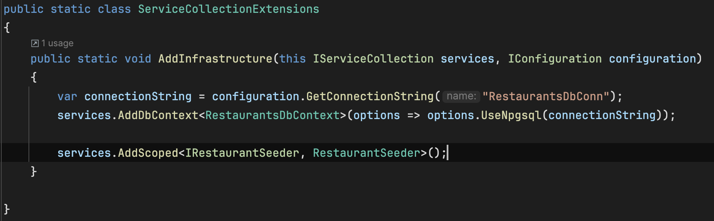
- Then we need to invoke seed method:
  - Open program.cs
  - Create a new scoped
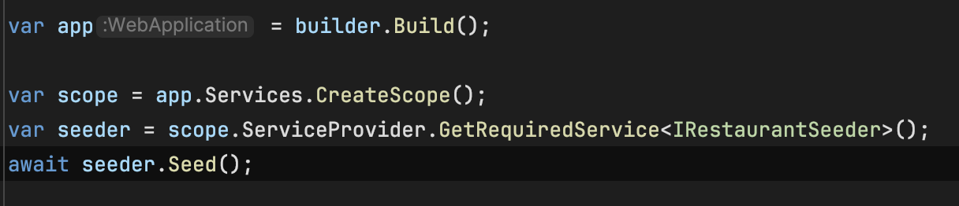

- Run the application and we can see the data will be created in the database

Data Seeding Overview

To seed initial data into the database, you follow these key steps:
- Create a Seeder Class
  - Add a dedicated class (e.g., RestaurantSeeder) inside a Seeders folder within the Infrastructure layer.
  - This class handles inserting default data into the Restaurant table.
- Implement the Seeder Interface
  - Create and expose a public interface (e.g., IRestaurantSeeder).
  - The RestaurantSeeder class implements this interface and defines the seeding method.
- Inject the DbContext
  - Inject the RestaurantDbContext through the RestaurantSeeder constructor.
  - This allows the seeder to read and write database records.
- Define the Seeding Logic
  - Implement a method such as SeedAsync() to:
    - Check whether the target table contains data.
    - Insert default records only if the table is empty.
- Trigger Seeding in Program.cs
  - In Program.cs, create a service scope, retrieve the IRestaurantSeeder, and call SeedAsync().
  - Use await to ensure seeding completes before the application fully starts.

